**HPA QN**

1. url: <https://github.com/devopsexamus/nodejsapp.git>
2. so this is the url provided
3. previous exam I pushed the node image for the same application so im going to use it
4. I tried to pull my image



* Im getting an **error like error limit of pulling** the image …
* I asked **my hr team** and they said to me to put the screenshot cant call my sir
* Soo im putting the screenshot
* Because of **the vm issue** I cant solve this problem because of cant pull image let me do the steps and please consider this

1. **created a deployment**



**Commad:**

kubectl create deploy nodejs-deployment –image=abhiramikannan/nodejs-image –dry-run=client -o yaml >node-deploy.yaml

1. **cat node-deploy.yaml**

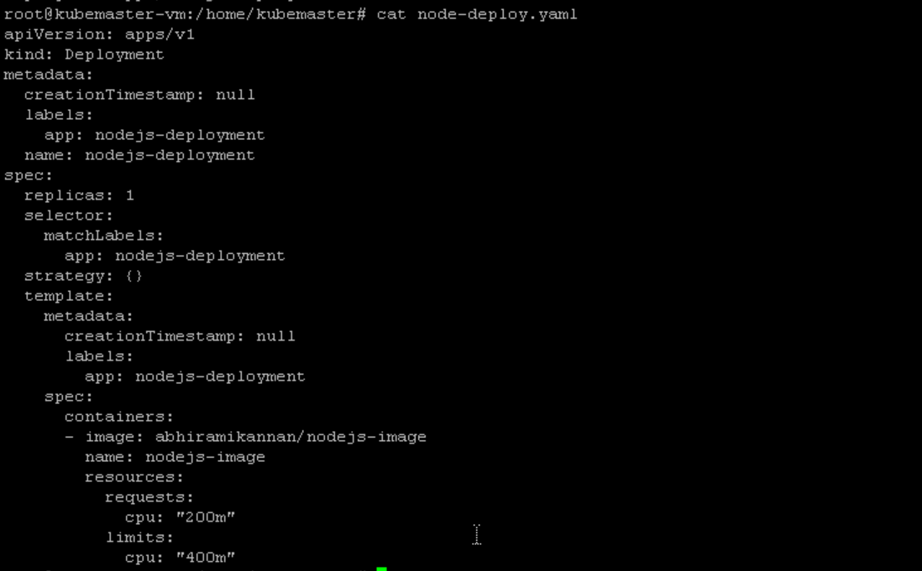

1. command: **kubectl apply -f node-deploy.yaml**



Here created a deployment

1. **kubectl get deploy**

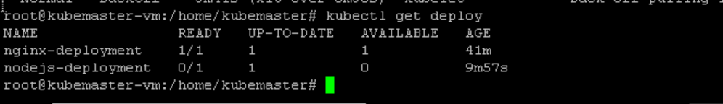

1. it was not created so lets check what is the reason ..kubectl get pods

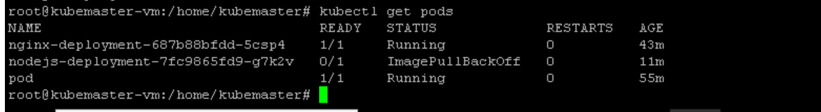

Here also the pods are not created

1. **describing the pods**

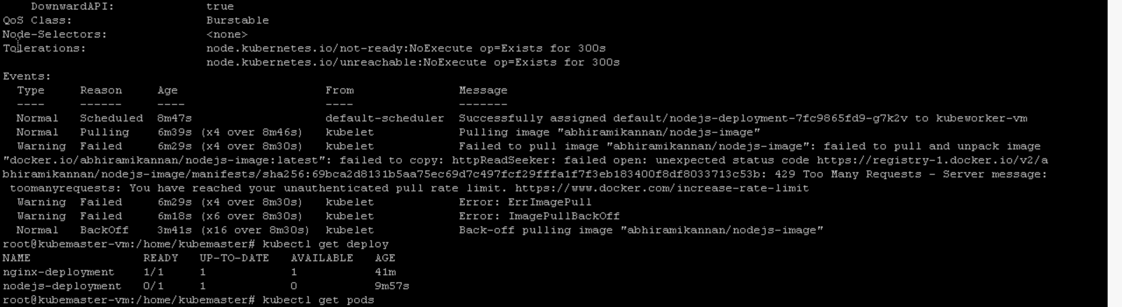

**Soo pulling rate limit error is there**

Soo I again asked my hr and his team to help somethg ,they said just put screenshot nothing can be done

1. so im going to create a **hpa**



**Command:**

Kubectl autoscale deploy nodejs-deployment –min=1 –max=5 –cpu-percent=50

So I have created the hpa

* And im going inside a pod and giving stress to check whether the pod is scaling or not according to hpa

1. I cant **get inside the pod because of this image issue**



1. So I will show you how to **do hpa by entering into different pod**



I get inside my nginx pod and put load inside

I have give infinite loop

1. Then if I watch-n 1 kubectl get pods I can see the pods are scaling
2. In my case I cant show due to the image pull error
3. **Testing part is this**

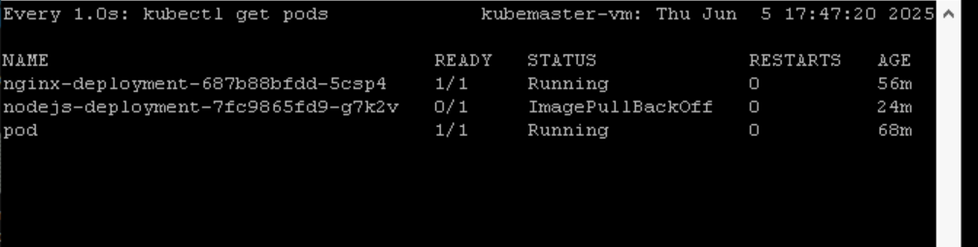

1. So this command in other terminal will show you the **pods which are scaling**
2. We can **see the pods are coming up**
3. Here it wont show because I used another deployment pod for show this
4. For me I started the exam very late due to **the vm issue** I cant able to login first,then my **pods in the namesystem was not coming up**
5. Calico was not there
6. Api server was not there
7. Then they gave another machine
8. But I got **rate limit**
9. Because everyone is pulling **from same ip**
10. **Hr team didn’t help me** soo this only I can do this is my hpa and documentation